CASE STUDY: Real-Time Retail Analytics Pipeline
Business Goal
Build a pipeline to:
- Ingest orders (batch + streaming)
- Transform data in Snowflake
- Serve dashboards to business users

ARCHITECTURE OVERVIEW
Azure Pipeline
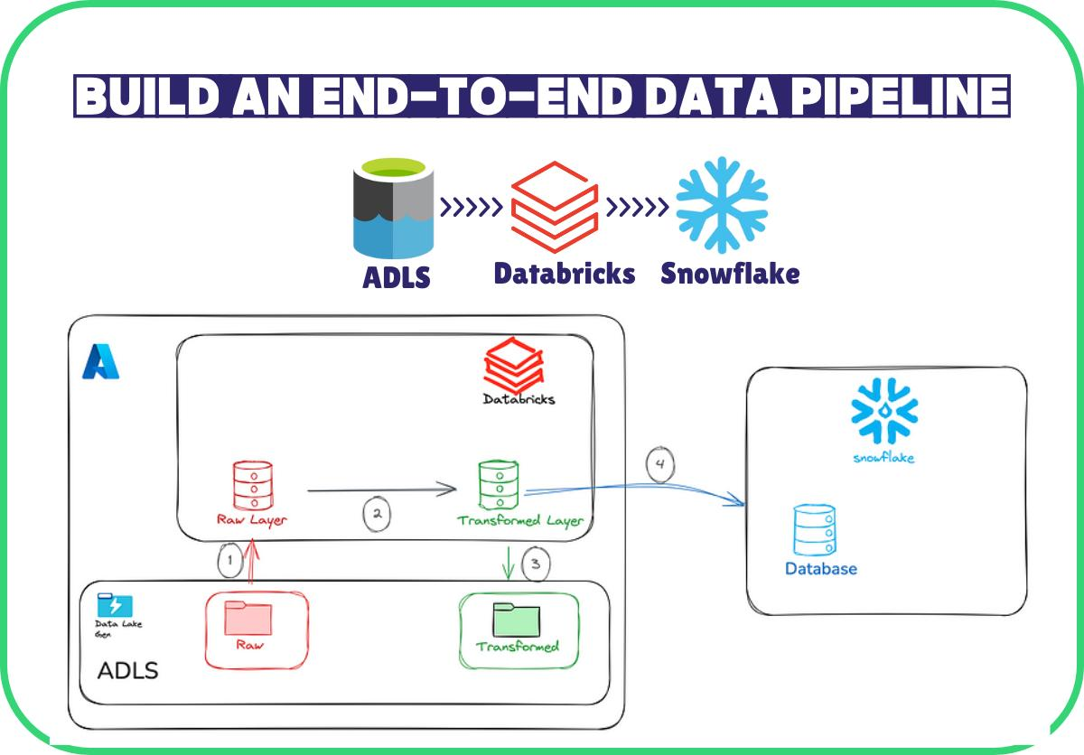
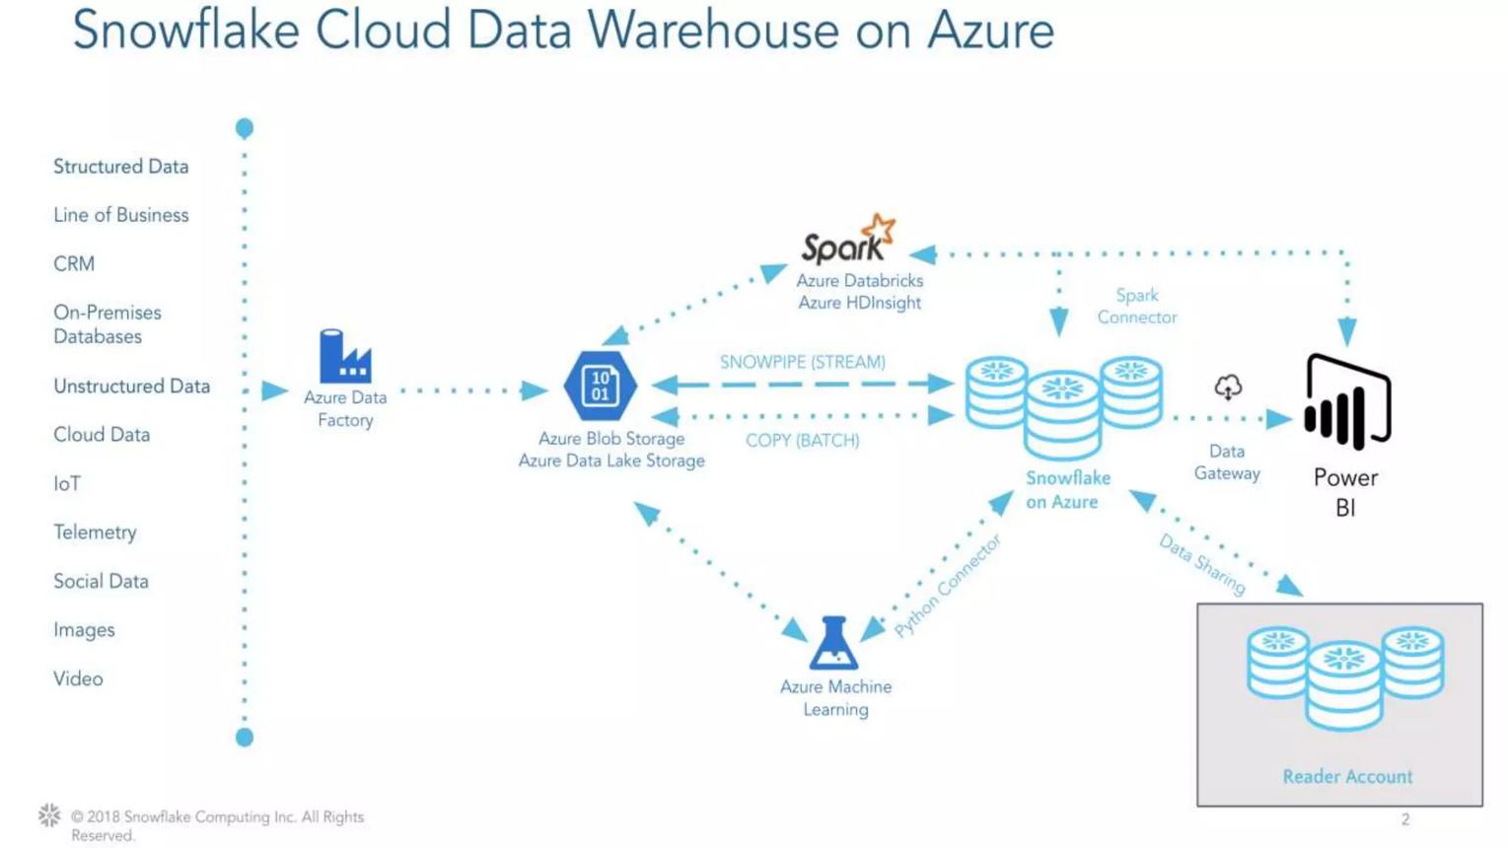
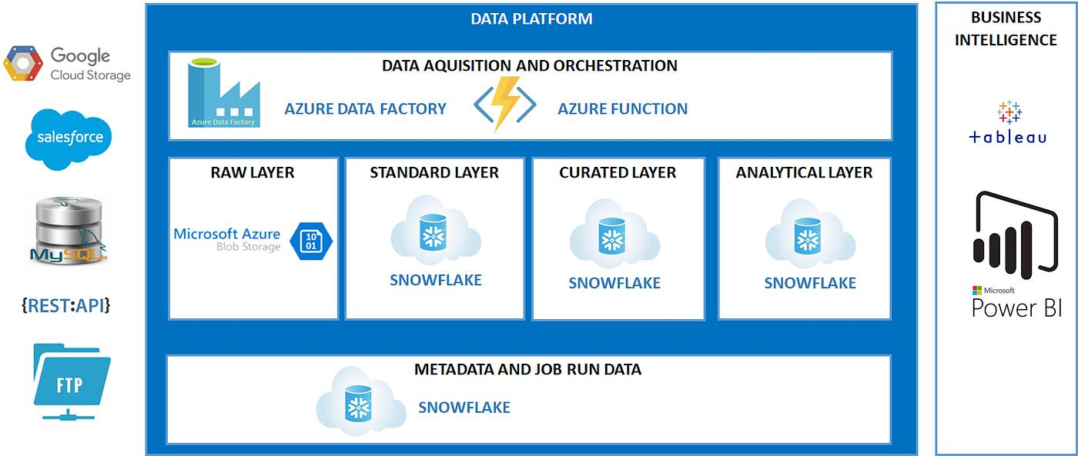
Flow:
- App → JSON files
- Azure Blob Storage
- Azure Data Factory
- Snowflake
- Power BI

GCP Pipeline
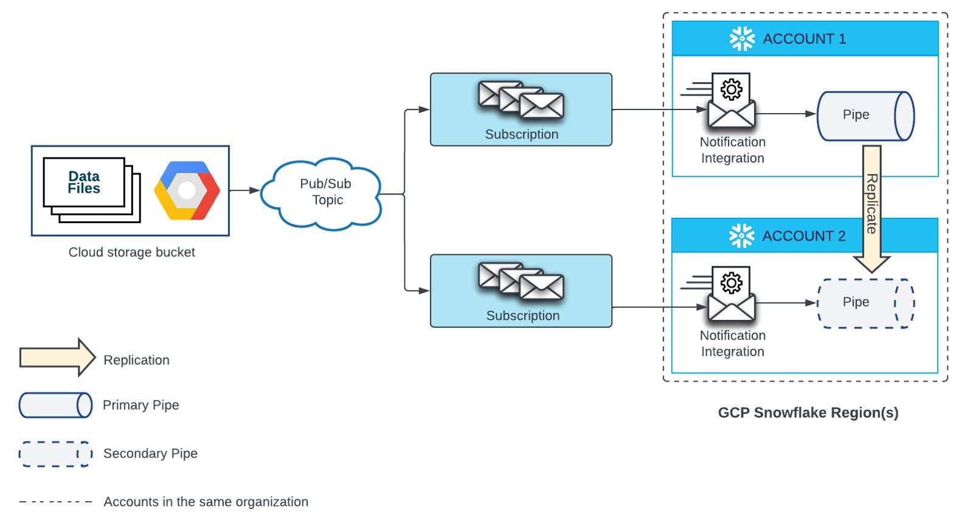
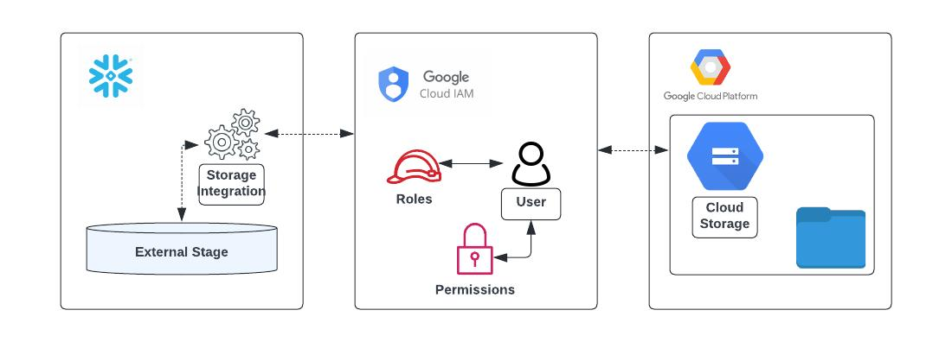
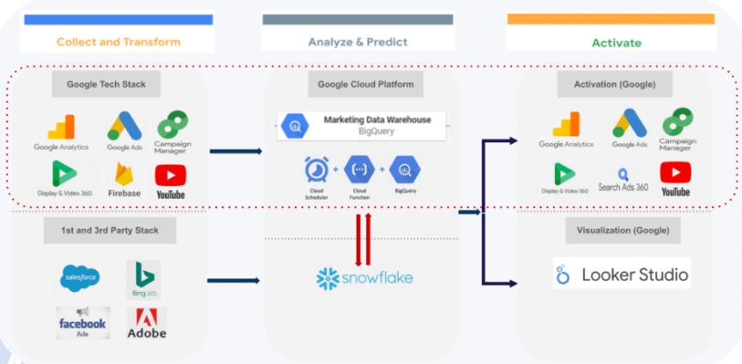
Flow:
- Events → Google Pub/Sub
- Processing → Dataflow
- Storage → Google Cloud Storage
- Snowflake → Analytics
- Looker

PART 1 — SNOWFLAKE SETUP (COMMON)
Step 1: Create DB & Schema
CREATE DATABASE RETAIL_DB;
CREATE SCHEMA RETAIL_DB.RAW;
CREATE SCHEMA RETAIL_DB.TRANSFORM;
CREATE SCHEMA RETAIL_DB.ANALYTICS;

Step 2: Create File Format
CREATE FILE FORMAT JSON_FORMAT TYPE = JSON;

Step 3: Create Raw Table
CREATE TABLE RETAIL_DB.RAW.ORDERS_RAW (
DATA VARIANT
);

Step 4: Create Warehouse
CREATE WAREHOUSE ETL_WH
WITH WAREHOUSE_SIZE = 'SMALL'
AUTO_SUSPEND = 60
AUTO_RESUME = TRUE;

PART 2 — AZURE PIPELINE (ADF → Snowflake)
Step 1: Upload Sample Data to Blob
Example JSON:
{
"order_id": 1,
"customer_id": 101,
"amount": 500,
"order_date": "2026-01-01"
}
Upload to:
blob://retail/orders/orders_1.json

Step 2: Create Storage Integration in Snowflake
CREATE STORAGE INTEGRATION azure_int
TYPE = EXTERNAL_STAGE
STORAGE_PROVIDER = AZURE
ENABLED = TRUE;

Step 3: Create External Stage
CREATE STAGE orders_stage
URL='azure://retail.blob.core.windows.net/orders'
STORAGE_INTEGRATION = azure_int
FILE_FORMAT = JSON_FORMAT;

Step 4: Load Data
COPY INTO RETAIL_DB.RAW.ORDERS_RAW
FROM @orders_stage;

Step 5: ADF Pipeline
In Azure Data Factory:
Create pipeline:
- Source → Blob Storage
- Sink → Snowflake (via COPY command or connector)
- Trigger → Schedule (every 5 mins)

PART 3 — GCP PIPELINE (Pub/Sub → Snowflake)
Step 1: Create Topic
In Google Pub/Sub:
topic: orders-topic

Step 2: Publish Message
{
"order_id": 2,
"customer_id": 102,
"amount": 700
}

Step 3: Dataflow Job
Use Dataflow:
- Read from Pub/Sub
- Write JSON to GCS

Step 4: GCS Bucket
Store data in:
gs://retail/orders/

Step 5: Snowflake Stage
CREATE STAGE gcs_stage
URL='gcs://retail/orders'
FILE_FORMAT = JSON_FORMAT;

Step 6: Load Data
COPY INTO RETAIL_DB.RAW.ORDERS_RAW
FROM @gcs_stage;

PART 4 — TRANSFORMATION (SNOWFLAKE)
Step 1: Parse JSON
CREATE TABLE RETAIL_DB.TRANSFORM.ORDERS AS
SELECT
DATA:order_id::INT AS ORDER_ID,
DATA:customer_id::INT AS CUSTOMER_ID,
DATA:amount::FLOAT AS AMOUNT,
DATA:order_date::DATE AS ORDER_DATE
FROM RETAIL_DB.RAW.ORDERS_RAW;

Step 2: Aggregation
CREATE TABLE RETAIL_DB.ANALYTICS.SALES_SUMMARY AS
SELECT
ORDER_DATE,
SUM(AMOUNT) AS TOTAL_SALES
FROM RETAIL_DB.TRANSFORM.ORDERS
GROUP BY ORDER_DATE;

PART 5 — BI DASHBOARD
Option 1: Power BI
Connect Power BI:
- Connector → Snowflake
- Import → SALES_SUMMARY
Create:
- Sales trend chart
- KPI: Total Revenue

Option 2: Looker
Use Looker:
- Connect Snowflake
- Build dashboard

PART 6 — AUTOMATION (ADVANCED)
Snowpipe (Real-Time Ingestion)
CREATE PIPE orders_pipe
AUTO_INGEST = TRUE
AS
COPY INTO RETAIL_DB.RAW.ORDERS_RAW
FROM @orders_stage;

Stream + Task (Incremental Processing)
CREATE STREAM orders_stream ON TABLE RETAIL_DB.RAW.ORDERS_RAW;
CREATE TASK transform_task
WAREHOUSE = ETL_WH
SCHEDULE = '1 MINUTE'
AS
INSERT INTO RETAIL_DB.TRANSFORM.ORDERS
SELECT ...
FROM orders_stream;

PART 7 — COST & PERFORMANCE
Resource Monitor
CREATE RESOURCE MONITOR rm1
WITH CREDIT_QUOTA = 100
TRIGGERS ON 100 PERCENT DO SUSPEND;

Best Practices
- Use SMALL warehouse for BI
- Use LARGE for ETL
- Enable auto-suspend
- Partition large tables

FINAL DATA FLOW (END-TO-END)
Azure / GCP
↓
Storage (Blob / GCS)
↓
Snowflake Stage
↓
RAW (JSON)
↓
TRANSFORM (Structured)
↓
ANALYTICS (Aggregated)
↓
BI Dashboard

